

**Department of Software Engineering**

**Faculty of Computer Science & Information Technology**

**The Superior University, Lahore**

**Name:** MUHAMMAD HAMZA ALI

**Roll No:** SU92-BSAIM-S24-032

**Section:** 3A

**Subject:** ARTIFICIAL INTELLIGENCE(LAB)

**Task No:** Lab-Task 4(Task-1)

**Task-4**

**LUHN Algorithm**

**1. Introduction:**

The LUHN Algorithm is a widely used checksum formula that helps validate identification numbers, particularly credit card numbers. This project implements the LUHN Algorithm in Python, allowing users to input a card number and determine its validity.

**2. Features:**

The LUHN Algorithm provides the following features:

* **User Input Handling:** Users can input a card number, with or without spaces.
* **Digit Processing:** The algorithm processes the card number to apply the LUHN checksum validation.
* **Validation Check:** Determines whether the card number is valid or invalid.

**3. Implementation Details:**

The program is implemented in Python using a class-based structure.

1. Removes spaces from the input to handle formatted card numbers.
2. Checks if the input contains only digits, otherwise, it returns False.
3. Converts the card number into a list of integers and reverses it.
4. Doubles every second digit from the right (starting from index 1).
5. If a doubled digit is greater than 9, subtracts 9 from it.
6. Computes the sum off all digits.
7. Checks if the total sum is divisible by 10, if so the card number is valid.

**4. User Interaction:**

* The user inputs a card number.
* The function processes the input and applies the LUHN validation steps.
* The result displayed, indicating whether the card number is valid on invalid.

**5. Example Usage:**

* Enter a card number: 4539 1488 0343 6467
* Card is Valid.
* Enter a card number: 8273 1232 7352 0569
* Card is Invalid.

**6. Output:**

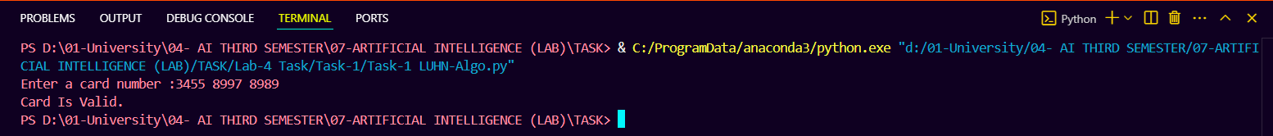

**7. Conclusion:**

The LUHN Algorithm implementation provides a simple and effective way to verify card numbers. Future enhancements may include support for different card types, GUI-based interaction, or integration with financial applications for automated validation.